1. Describe the purposes of the compression ( 1 marks)

Compression is used to reduce the amount of space taken up by a file in a storage device like a hard drive.

1. List **one** advantages and one disadvantage of Lossless and Lossy compression? ( 4 marks)

|  |
| --- |
| Lossless:   * Advantage: No quality is lost from the file. * Disadvantage: Is not as effective at reducing file size compared to lossy compression.   Lossy:   * Advantage: Compresses the file more compared to lossless compression, the file size is reduced further. * Disadvantage: The quality of the file may be lost or reduced. Pictures will get worse in quality, metadata may be lost. |

1. Construct an expression to calculate the size of a 24-bit image file displayed at a resolution of 400 x 250 pixels. Give your answer in kilobytes. ( 3 marks)

|  |
| --- |
| (400 * 250 * 24) / 1000  This expression calculates the size of a 24-bit image file displayed at a resolution of 400 x 250 pixels. |

1. A car dealer uses the following algorithm to determine the price to charge for cars.

|  |  |  |
| --- | --- | --- |
|  | 01 p = input(“purchase price of car”) 02 i = input(“number of improvements made”)  03 a = input(“age of car in years”)  04 s = p + (i*100)  05 if a <= 10 then  06 s = s + s  07 end if  08 print “sale price is “ + s |  |

Work out the output value with the following inputs: (3 marks)

i. p = 1000, i = 2, a = 12

|  |
| --- |
| s = p + (i*100)  s = 1000 + (2 * 12)  <a is not less than or equal to 10>  s = 1,200  **output: “sale price is 1200”** |

ii. p = 5000, i = 3, a = 10

|  |
| --- |
| s = p + (i*100)  s = 5000 + (3 * 100)  <a is less than or equal to 10>  s = s + s  s = 5,300 + 5,300  s = 10,600  **output: “sale price is 10600”** |

iii. Rewrite line 06 so that the + operator is **not** used.

|  |
| --- |
| s *= 2 |

1. Study this algorithm and then answer the questions below. ( 9 marks)
2. Receive Time From User
3. IF time = 'breakfast' THEN
4. q =1
5. ELSE IF time = 'lunch' THEN
6. q =4
7. ELSE IF time = 'dinner' THEN
8. a =2
9. ELSE
10. OUTPUT 'time not recognised'
11. ENDIF
12. FOR n =1 TO q
13. IF n < 3 THEN
14. DISPENSE_BISCUIT('chewies')
15. ELSE
16. DISPENSE_BISCUIT('crunchy')
17. ENDIF
18. ENDFOR

|  |
| --- |
| State the line number that where selection is FIRST used in the algorithm. |
| 2 |
| State the line number that where iteration is FIRST used in the algorithm. |
| 11 |
| How many times the subroutine **DISPENSE_BISCUIT** would be called if the user input is **'breakfast'**.? |
| 1 |
| State how many times the subroutine **DISPENSE_BISCUIT** will be called with the parameter **'chewies'** if the user input is **'lunch**' |
| 2 |
| What is the data type of the variable ***time*** in the algorithm |
| string |
| State how many possible values the result of the comparison ***time = 'dinner'*** could have in the algorithm? |
| 0 |
| The programmer realises they have made a mistake. State the line number of the algorithm. |
| Line 7 |
| Write ONE line of code that would correct the error found in the algorithm. |
| q = 2 |
| A syntax error is another type of error. Give a definition of a syntax error. |
| When code is not written in a valid way. |

1. Write a program that asks the user to enter two subjects and tells them which department are they in. ( 10 marks)

|  |  |
| --- | --- |
| **Department** | **Subjects** |
| Engineering | Maths and Physics |
| Medicine | Chemistry and Biology |
| Law | Politics or English |
| Computer Science | Computing or ICT |
|  |  |

Submit screenshots of the code and the results for two different departments as output.

**Code:**

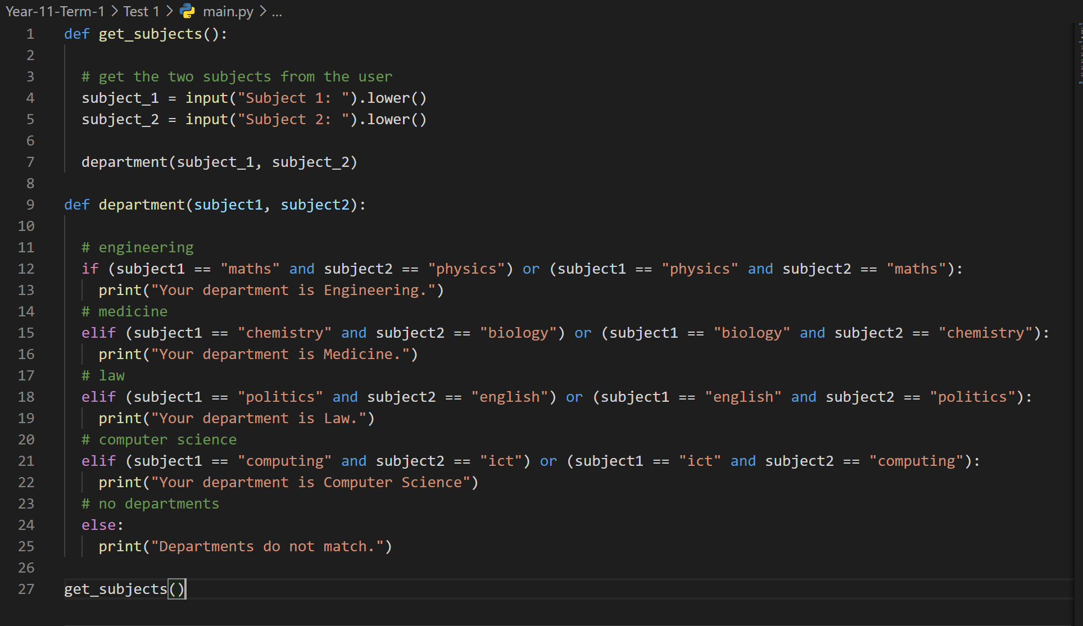

**Outputs:**

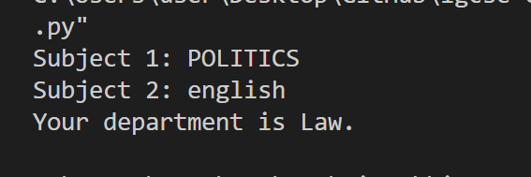

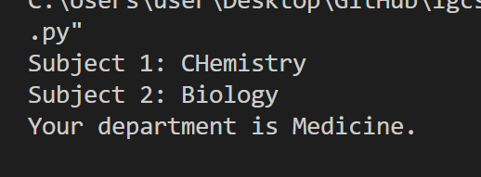

Total marks 30.